ABASYN UNIVERSITY
ISLAMABAD CAMPUS

Name: Khalid Saif Ullah
ID: 24732
Subject: MAD
Assignment No: 02
Teacher: Dr. Sadaf Tanvir

Question 1 SRS

1. Introduction

1.1 Purpose:
The purpose of the Restaurant App is to make dining easier for customers.
Customers can browse the menu, search for food, add items to a cart, reserve a table, place an order, and track their order.
Restaurant managers can manage orders, reservations, and menu items.
The app uses a backend server and database to keep information centralized and consistent between users.

1.2 Scope:
The app will provide:
- Customer and manager login/signup
- Menu browsing
- Food search and filtering
- Shopping cart
- Promo codes
- Order summary
- Table reservations
- Order tracking
- Customer profile
- Light and dark themes
- Manager dashboard
- Menu and order management
- Backend server
- MongoDB database
- REST APIs
- JWT authentication
- Centralized data storage
The following are out of scope:
- Real online payments
- Push notifications
- Real restaurant payment processing
The app will use a Node.js and Express server with MongoDB for storing and managing application data.

1.3 Definitions and Acronyms:
- SRS: Software Requirements Specification; a document describing what the app should do.
- MVP: Minimum Viable Product; the basic working version of the app.
- UML: A standard way of drawing and explaining a software system.
- Hook: A React feature used to manage state and other functions in components.
- Context: A way to share data across different screens without passing it through every component.
- Reducer: A function that manages changes to complex state.
- API: A way for the mobile app and server to communicate.
- REST: A standard way of designing web APIs using HTTP methods.
- Endpoint: A specific URL used to access a server operation.
- JSON: A format used to exchange data between the app and server.
- MongoDB: A NoSQL database used to store application data.
- Collection: A group of related documents in MongoDB.
- Mongoose: A library used by Node.js to connect to and work with MongoDB.
- Middleware: Code that runs between a request and response, such as authentication or error handling.
- JWT: A token used to authenticate users and protect server routes.

2. Overall Description

2.1 User Roles:
Users and their permissions and goals:
- Customer: Customer can browse food, search menu, add items to cart, reserve tables, place orders, and track orders.
- Manager: Manager manages orders, reservations, menu items, prices, and item availability.

2.2 User Stories:

Customer:
- As a customer, I want to browse the menu so that I can decide what to eat.
- As a customer, I want to search for food so that I can find an item quickly.
- As a customer, I want to see daily specials so that I can discover special offers.
- As a customer, I want to add food to my cart so that I can place an order.
- As a customer, I want to apply a promo code so that I can receive a discount.
- As a customer, I want to reserve a table so that I have a place when I arrive.
- As a customer, I want to choose a table according to my party size so that everyone has enough space.
- As a customer, I want to track my order so that I know its current status.
- As a customer, I want my account and orders to be stored on the server so that my information is not lost when I change devices.

Restaurant Manager:
- As a manager, I want to view incoming orders so that I can manage them.
- As a manager, I want to update order status so that customers can see their progress.
- As a manager, I want to manage reservations so that I can accept or decline bookings.
- As a manager, I want to edit menu items so that the menu stays updated.
- As a manager, I want changes to menu items to be visible to customers so that everyone sees the latest information.

3. Functional Requirements

Authentication:
FR-01: The system shall allow users to log in with an email and password.
FR-02: The system shall allow new users to create an account.
FR-03: The system shall validate email and password information.
FR-04: The system shall identify users as Customer or Manager.
FR-05: The system shall use JWT tokens to protect authenticated operations.
FR-06: The system shall prevent customers from accessing manager-only operations.

Menu:
FR-07: The system shall display available menu items.
FR-08: The system shall organize menu items into categories.
FR-09: The system shall show item names, descriptions, prices, images, and availability.
FR-10: The system shall mark special items as Daily Specials.
FR-11: The system shall allow managers to add, edit, and delete menu items through the server.
FR-12: The system shall allow managers to change menu item availability.

Search:
FR-13: The system shall allow customers to search for menu items.
FR-14: The system shall allow customers to filter menu items by category.
FR-15: The system shall show a message when no matching item is found.

Cart:
FR-16: The system shall allow customers to add menu items to the cart.
FR-17: The system shall allow customers to increase or decrease item quantities.
FR-18: The system shall allow customers to remove items from the cart.
FR-19: The system shall allow customers to add special instructions to cart items.
FR-20: The system shall allow customers to apply valid promo codes.

Reservation:
FR-21: The system shall allow customers to select a date and time for a reservation.
FR-22: The system shall check table availability based on date, time, and party size.
FR-23: The system shall prevent a table from being booked when it is already reserved.
FR-24: The system shall allow customers to view their reservations.
FR-25: The system shall allow managers to accept or decline reservations.

Orders:
FR-26: The system shall allow customers to place an order.
FR-27: The system shall calculate the order total using prices stored in the database.
FR-28: The system shall display the order total before placing an order.
FR-29: The system shall display the current order status.
FR-30: The system shall allow managers to update order status.
FR-31: The system shall allow customers to view their previous orders.
FR-32: The system shall allow order status to move from Pending to Preparing, Ready, and Served.
FR-33: The system shall only allow cancellation while an order is Pending.

Manager Dashboard:
FR-34: The system shall allow managers to view incoming orders.
FR-35: The system shall allow managers to update order status.
FR-36: The system shall allow managers to accept or decline reservations.
FR-37: The system shall allow managers to add and edit menu items.
FR-38: The system shall allow managers to change menu item availability.

4. Non-Functional Requirements

Usability:
The app should have simple navigation and clear buttons so customers can easily find menus, carts, reservations, and orders.

Performance:
Menu lists should scroll smoothly, and API requests should complete without unnecessary delays.

Responsiveness:
The interface should work properly on different mobile screen sizes.

Maintainability:
The project should use organized folders, reusable components, contexts, reducers, hooks, API files, routes, controllers, and models.

Data Handling:
Application data will be stored in MongoDB through the backend server. The mobile application will communicate with the server using REST APIs.

Security:
Passwords shall be stored as encrypted hashes. Protected server operations shall require a valid JWT token, and manager operations shall require manager authorization.

5. API Requirements
The backend will provide REST API endpoints under /api.
Method | Endpoint | Access | Purpose
POST | /api/auth/register | Public | Create account
POST | /api/auth/login | Public | Login
GET | /api/menu | Public | Get menu
GET | /api/menu/:id | Public | Get one menu item
POST | /api/menu | Manager | Add menu item
PUT | /api/menu/:id | Manager | Edit menu item
DELETE | /api/menu/:id | Manager | Delete menu item
POST | /api/orders | Customer | Create order
GET | /api/orders/my | User | Get own orders
GET | /api/orders | Manager | Get all orders
PATCH | /api/orders/:id/status | Manager | Update order status
POST | /api/reservations | Customer | Create reservation
GET | /api/reservations/my | User | Get own reservations
GET | /api/reservations | Manager | Get all reservations
PATCH | /api/reservations/:id | Manager | Accept/decline reservation
GET | /api/health | Public | Check server status
Common HTTP status codes used by the API are:
- 200: Successful request
- 201: Resource created
- 400: Invalid request
- 401: Authentication required
- 403: Access denied
- 404: Resource not found
- 409: Conflict
500: Server error

6. Database Data Model
The application uses a MongoDB database named restaurant_app.
Data Set | Main Fields | Purpose
Users | id, name, email, password, role | Stores customer and manager information
MenuItems | id, name, description, price, category, image, isSpecial, isAvailable | Stores restaurant food
Tables | id, tableNumber, seats, available | Stores restaurant tables
Reservations | id, userId, tableId, date, time, partySize, status | Stores table bookings
Orders | id, userId, items, total, status, timestamps | Stores customer orders

7. MVP Frontend Development

7.1 Login and Signup:
Purpose: Allow customers and managers to create accounts and log in through the server.
Main UI: Email, password, name, confirm password, role selector, login/signup buttons.
Hooks: useState, useContext

7.2 Menu Browsing:
Purpose: Allow customers to browse restaurant food received from the server.
Main UI: Categories, food cards, prices, images, availability, Daily Special badge.
Hooks: useState, useEffect, custom API hook

7.3 Search and Scroll Controls:
Purpose: Help customers quickly find food and navigate a long menu.
Main UI: Search bar, suggestions, clear button, Back to Top button.
Hook: useRef

7.4 Profile and Theme:
Purpose: Show user information and allow the customer to change the app theme.
Main UI: Name, email, role, light/dark switch, logout.
Hooks: useContext, custom hooks

7.5 Cart:
Purpose: Allow customers to review and modify their selected food.
Main UI: Items, quantities, notes, remove buttons, promo code.
Hook: useReducer

7.6 Order Summary:
Purpose: Show the complete cost before an order is placed.
Main UI: Subtotal, service charge, tax, discount, grand total.
Hooks: useMemo, useCallback
The final order total will be verified and calculated by the server using database prices.

7.7 Table Reservation:
Purpose: Allow customers to reserve an available table through the server.
Main UI: Date, time, party size, table availability, contact information, confirmation.
Hooks: Custom hooks, useEffect

7.8 Order Tracking and Manager Dashboard:
Purpose: Allow customers to track orders and managers to manage restaurant operations through the backend.
Customer: Track order progress and view order history.
Manager: Manage orders, reservations, menu items, prices, and availability.
The customer app will periodically request updated order information from the server so that status changes can be displayed without restarting the app.

7.9 Server and Database:
Purpose: Provide centralized storage and communication between the mobile app and database.
Technology: Node.js, Express, MongoDB, Mongoose.
The server will handle authentication, menu operations, orders, reservations, table availability, validation, and error handling.
Question 2 UML:
Use Case:
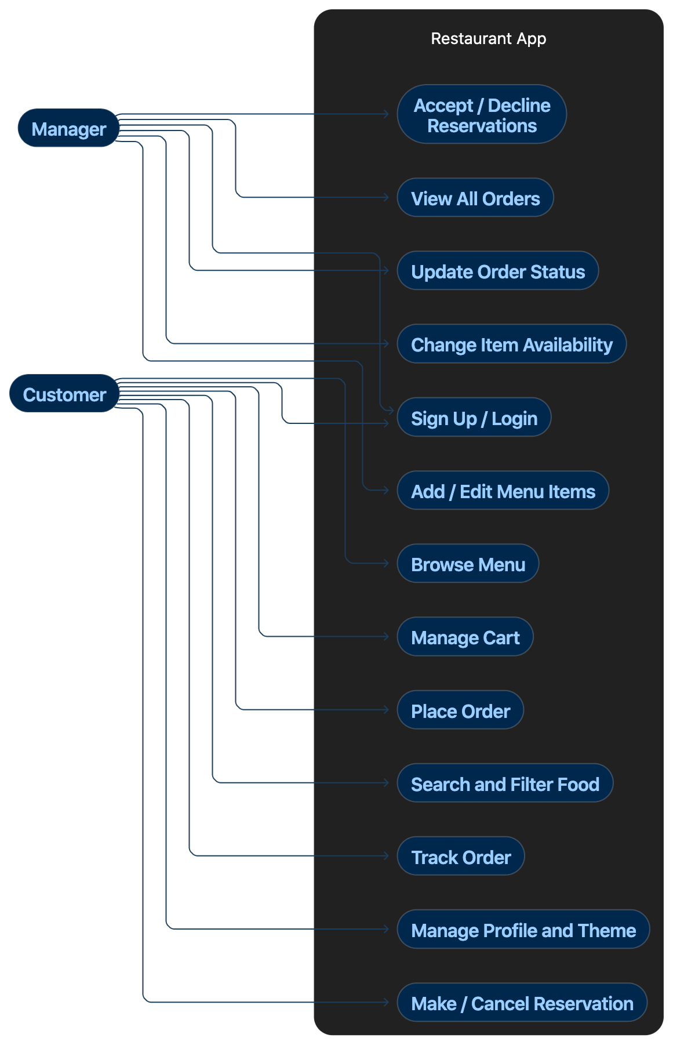
Shows the main features available to customers and managers in the restaurant app.
Class Diagram:
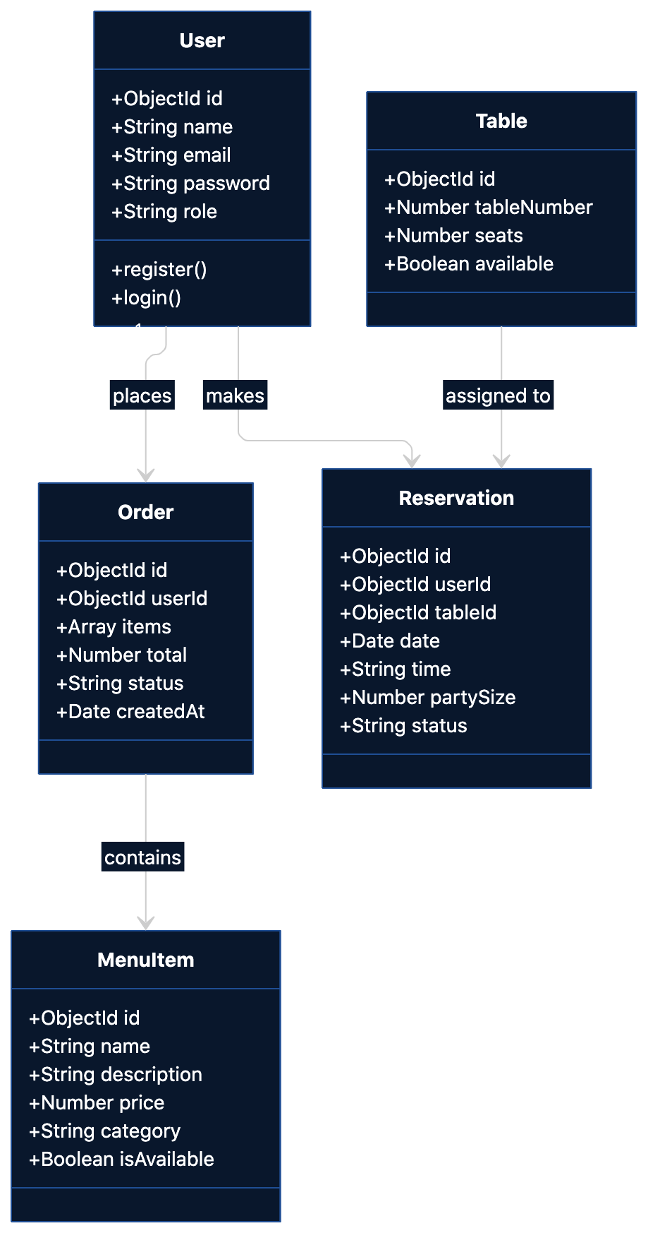
Shows the main data entities, their attributes, and relationships in the system.
Sequence Diagram:
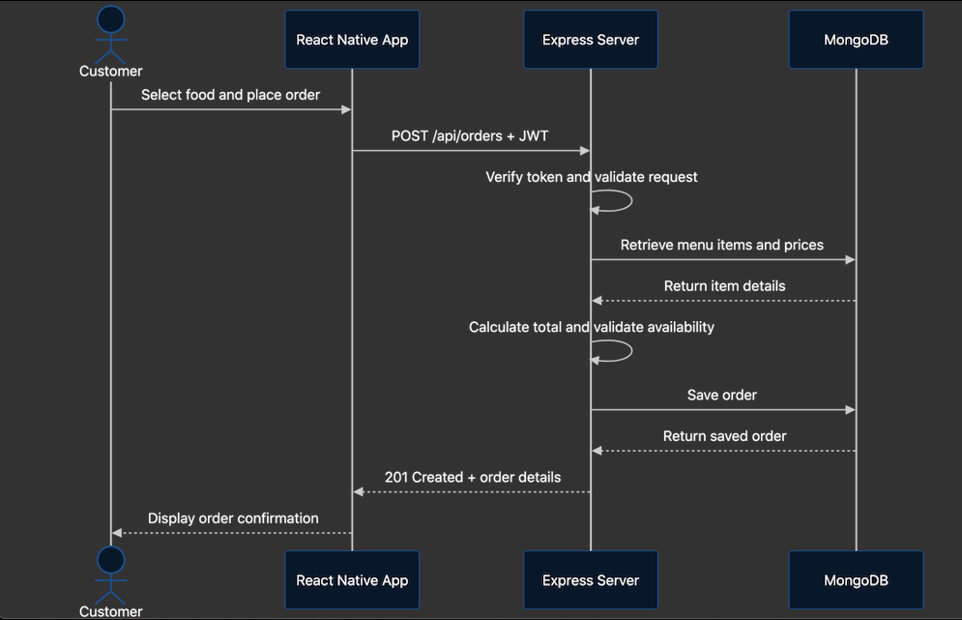
Shows how the app, Express server, and MongoDB communicate when a customer places an order.

Deployment Diagram:
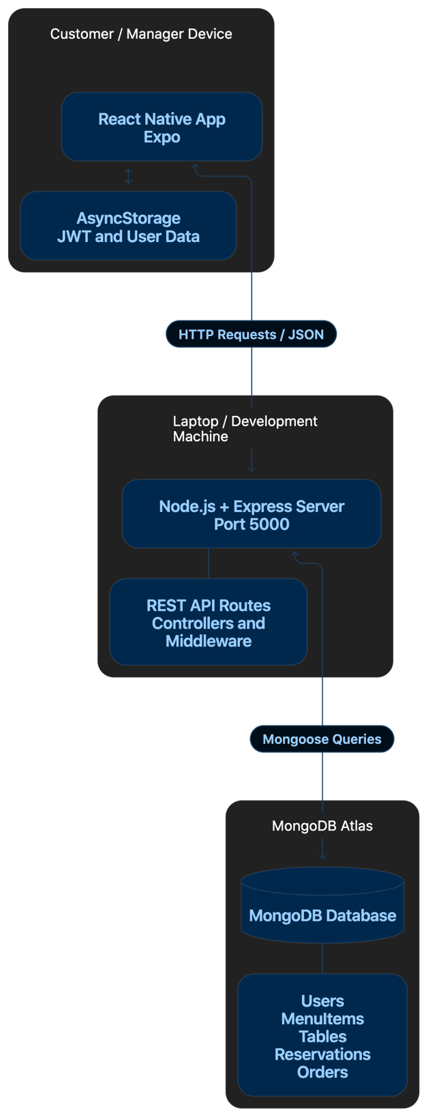
Shows where the app, backend server, and database are deployed and how they communicate.
Component Diagram:
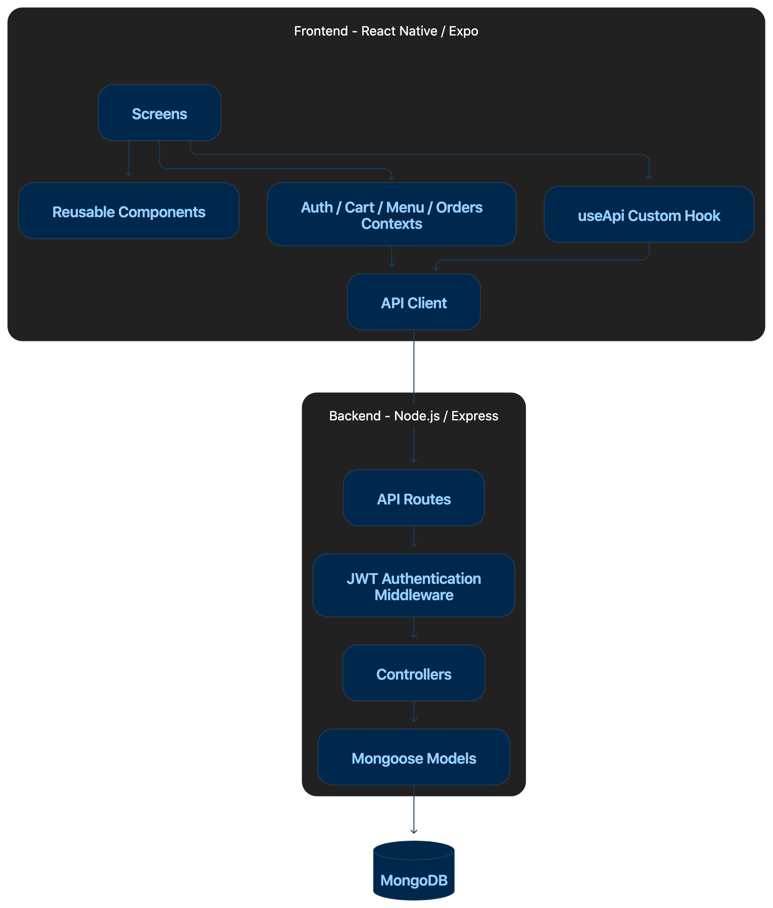
Shows the main frontend and backend components and how they interact with each other.

